JACKET

Office Use Only

___________ Receipt Date

________________Ship Date

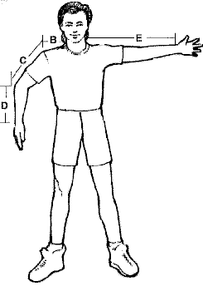

Measurements- Take measurements with the clothes on you would normally wear to skydive - include shoes.

1. Around neck ______________
2. Side of neck to shoulder ____________
3. Shoulder to elbow _____________
4. Elbow to wrist ____________
5. Total Arm length –side of neck to wrist ____________ straight arm held horizontal to floor
6. Wrist _________ Bicep___________ Forearm _________
7. Chest ____________ Women Only – Cup size _________
8. Waist____________
9. Hips ________

Height ___________Weight ___________ Sex_____________

Payment Method: Check Money Order MasterCard Visa Discover

Expiration Date: ______/______ (month/year) Security Code________________

Card Account Number **4% Service Charge on Credit Card Orders**

Name of Issuing Bank Customer Signature

***Price See Other***

***Options***

# Subtotal

**Rush $20 / Double $40**

### Pa Residents Add

6% Sales Tax

#### US Shipping Ground rate 18.00

Call for other options

# Total

# Balance Due

***Thank you for your order!***

____________ **Dealer**

**NAME**

**ADDRESS**

**CITY STATE ZIP**

**PHONE EMAIL**

**Shipping**

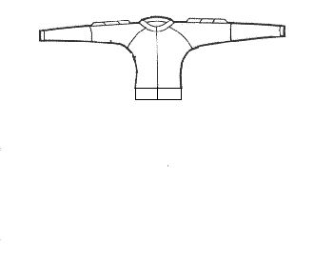

# Sit Style or Skysurf Style $220.00

# BODY COLOR ___________________

#### ARM COLOR ____________________________

#### WING COLOR_______________________

**TAPE AROUND WING COLOR**_________________

_____ Small wing if used for freestyle or skysurfing

### Camera Jacket with RSL clips $ 250.00

#### TORSO / COLOR _______________

#### WING COLOR / SIZE ________________

_____ Small (1)

_____ Medium (2)

_____ Large (3)

#### Without RSL Clips_____$230.00 Grippers $20______Color:_____________

#### TAPE COLOR - edge of wing _______________

#### FOREARMS / COLOR _________________

Polycotton forearm with punch thru cuff

Freefly Jacket $ 170.00

#### COLOR ON FRONT: COLOR ON BACK:

ARM (Upper)________________________ ARM (Upper)_________________

ARM (Lower)_______________________ ARM (Lower)__________________

TORSO ____________________________ TORSO _________________

Velcro Zipper Tab Included Grippers $20____________________

Competition Style Jacket $ 180.00

**Grippers included**

TORSO COLOR _______________________________

FOREARM COLOR ____________________________

GRIPPER COLOR ________________ TAPE COLOR __________________

GRIP STRIPES __________ 2 STRIPES 15.00__________ 2 STRIPES w/PIN 17.00

BACK COLOR ______________________ ( Grippers included )

**ALL JACKETS (FABRIC AND OPTIONS)**

FABRIC:

_____ Nylon _______2 Stripes on Arms $40.00

_____ Polycotton

_____ Supplex

Spandex waistband, collar, and cuffs color_________________ _____ Coolmax lining $18.00 _____Lining $15.00

_______Extra Pocket $10.00 Location:______________________

Jackets have a standard inside left chest pocket

Special Instructions_________________

__________________________________________________________________

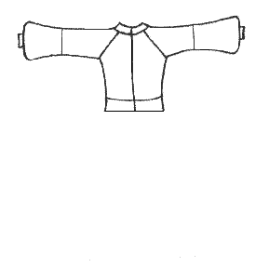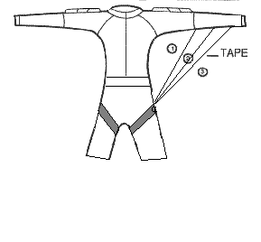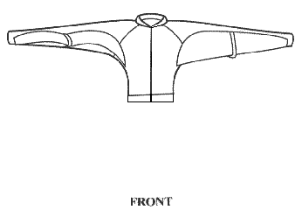

Jacket – Camera, Competition, Freestyle or Sit/ Skysurf

### 8398 Lyon Valley Rd. New Tripoli, PA 18066

### Phone & Fax (610) 285-6994

