Office Use Only

___________ Receipt Date

________________Ship Date

Camera Suit



Payment Method: Check Money Order MasterCard Visa Discover

Expiration Date: ______/______ (month/year) Security Code_____________

Card Account Number **4% Service Charge on Credit Card Orders**

Name of Issuing Bank Customer Signature

***Price See Other***

***Options***

# Subtotal

**Rush $20 / Double $40**

### Pa Residents Add

6% Sales Tax

#### US Shipping Ground rate 22.00

Call for other options

# Total

# Balance Due

***Thank you for your order!***

____________ **Dealer**

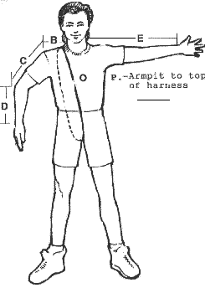

Measurements- Take measurements with the clothes on you would normally wear to skydive - include shoes.

1. Around neck ______________
2. Side of neck to shoulder__________
3. Shoulder to elbow ____________
4. Elbow to wrist _____________
5. Total Arm length- side of neck to wrist ___________ straight-arm held horizontal to floor.
6. Wrist_________ Bicep (flexed)_________ Forearm_____________
7. Chest ________ Women Only – Cup Size ______
8. Waist _______________
9. Hips ( fullest part) ____________
10. Upper Thigh (fullest part) _____________
11. Around and just above knee ____________
12. Crotch to just above knee ______________
13. Above knee to floor _______________
14. Crotch to floor __________ Regular Pants Inseam _______
15. Body length – shoulder at neck around crotch and back up around back to meet tape measure _________________
16. Armpit to top of harness ________________

Height ___________ Weight ________________ Sex _____________

**NAME**

**ADDRESS**

**CITY STATE ZIP**

**PHONE EMAIL**

**Shipping**

#### TORSO / COLOR _______________

_____ Nylon

_____ Polycotton

_____ Supplex

_____Lining $15.00

_____Coolmax Lining $25.00

_____ Velcro Zipper Tab $10.00

Our Camera suits are available with any combination of wing size and attachment. Small Wings attach at elbow Medium attach mid –forearm and Large attach at wrist. Choose the style that fits your needs

#### WING COLOR ________________

_____ **No Clip 345.00** Small (1)____ Med (2) ____ Large (3) ____

_____ **Clip 360.00**  Small (1) _______ Med (2) ____ Large (3) _____

#### Clip Placement: Hip Clip ______ Inner Thigh Clip_______

_____ **Velcro Sandwich with Thigh Clip 385.00**

Small (1) ______ Med(2) ______ Large (3)_________

#### TAPE COLOR - edge of wing _______________

#### FOREARMS / COLOR _________________

Polycotton forearm with punch thru cuff

#### POLYCOTTON LEG / COLOR _________________

_____ Straight leg

_____V Zippers on straight leg for Fast fall rate $30.00

_____ Booties $55.00 shoe size_______

_____ Cordura Booties $70.00 shoe size __________

____ Majik Bootie (Pleated) $90.00 shoe size_________

includes cordura knees

_____ Zippers on booties (12 inch) $ 25.00

_____ High Zippers on Booties (above knee) $ 30.00

_____ Afterburners $ 25.00 (slows fall rate)

_____ Cordura Seat $ 10.00 _____ Cordura Knees $10.00

#### SPANDEX BACK COLOR____________________

#### Suit comes with an inside left chest pocket and on right thigh

#### OPTIONAL

_____ Arm & Leg Gripper $40.00 color _____________

_____ Cordura Grippers $15.00

Tape color__________

Tape color will be to match unless specified

______ Two stripes $15.00 _______________

______Two stripes w/pin $17.00____________

______ Five stripes $30.00__________________

______ Extra Pocket $ 10.00 location _________________

Special Instructions ___________________________

___________________________________________

___________________________________________

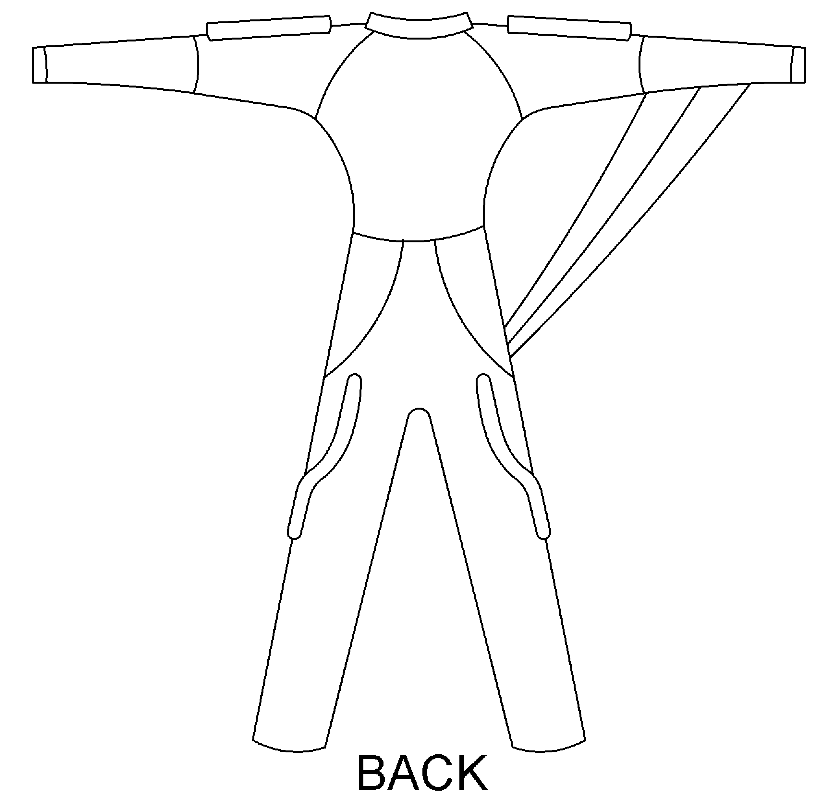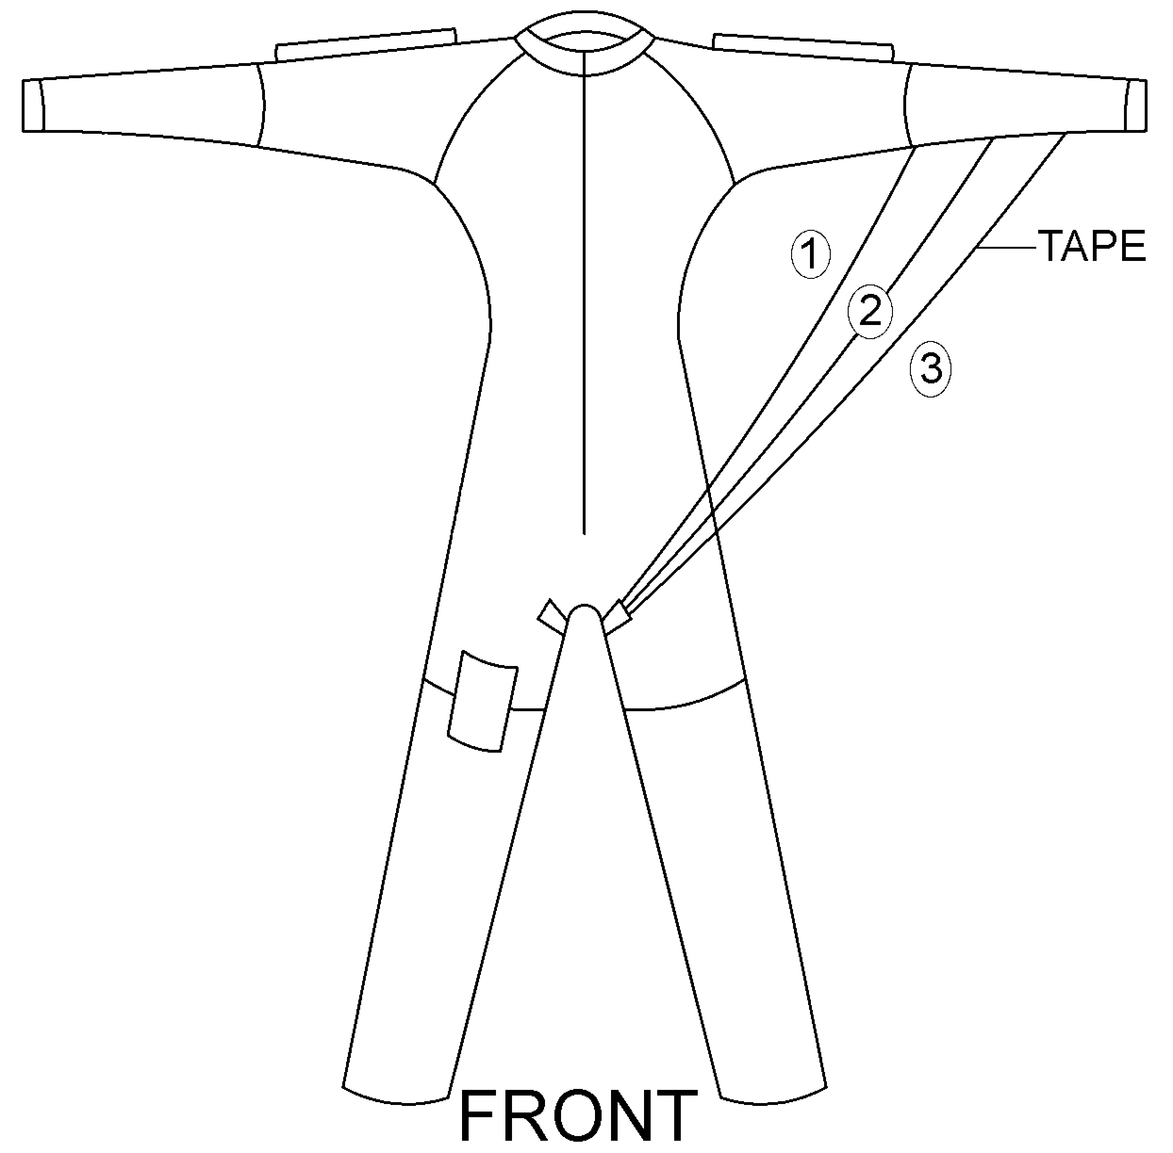

CAMERA SUIT

### 8398 Lyon Valley Rd. New Tripoli, PA 18066

### Phone & Fax (610) 285-6994

